Creating the USB Disk Image using FTK-Imager Software

Step 1 :- Select the source evidence type to Physical drive
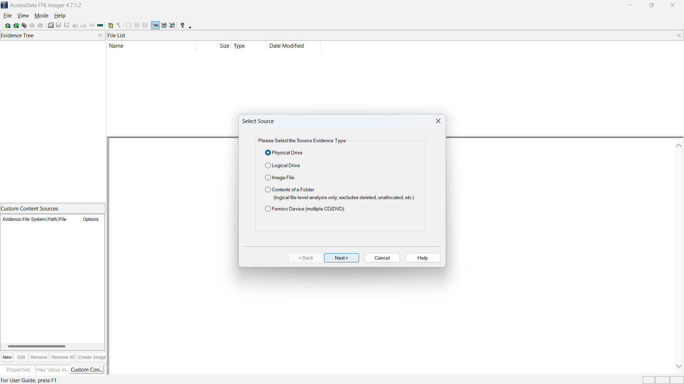

Step 2:- Select the USB-disk device
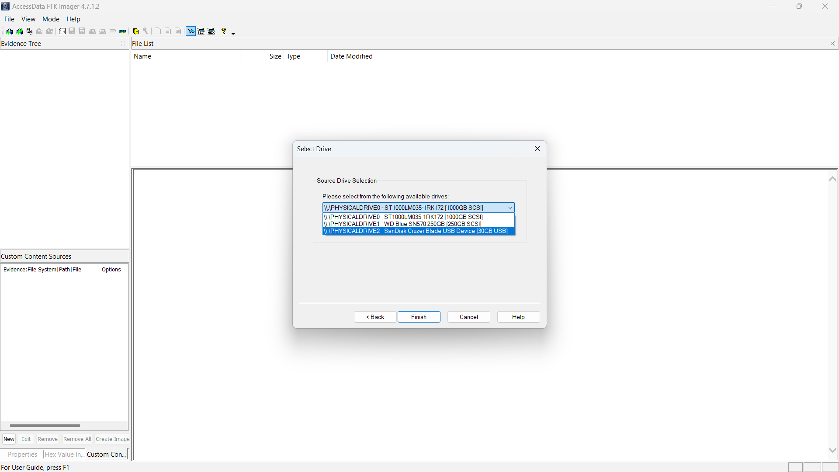

Step 3:- Add and select the image type to Raw(dd)
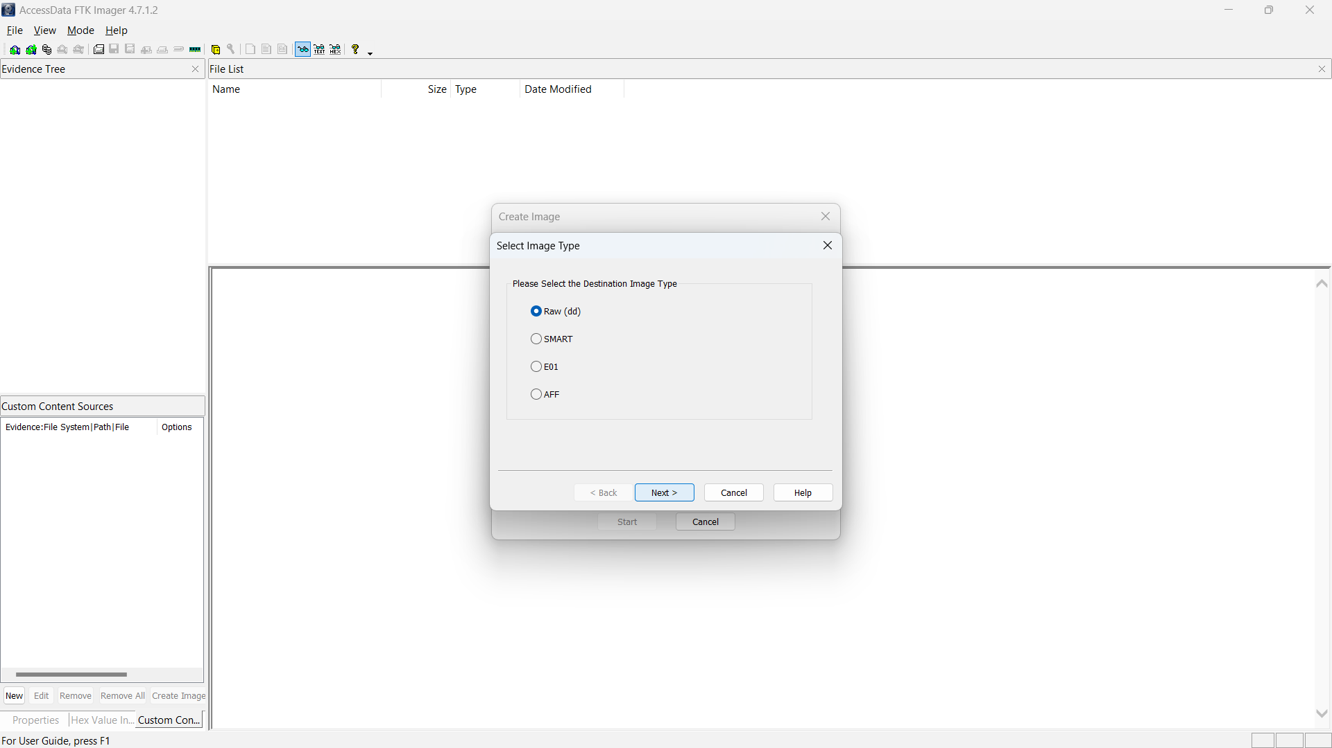

Step 4:- Fill the evidence item information
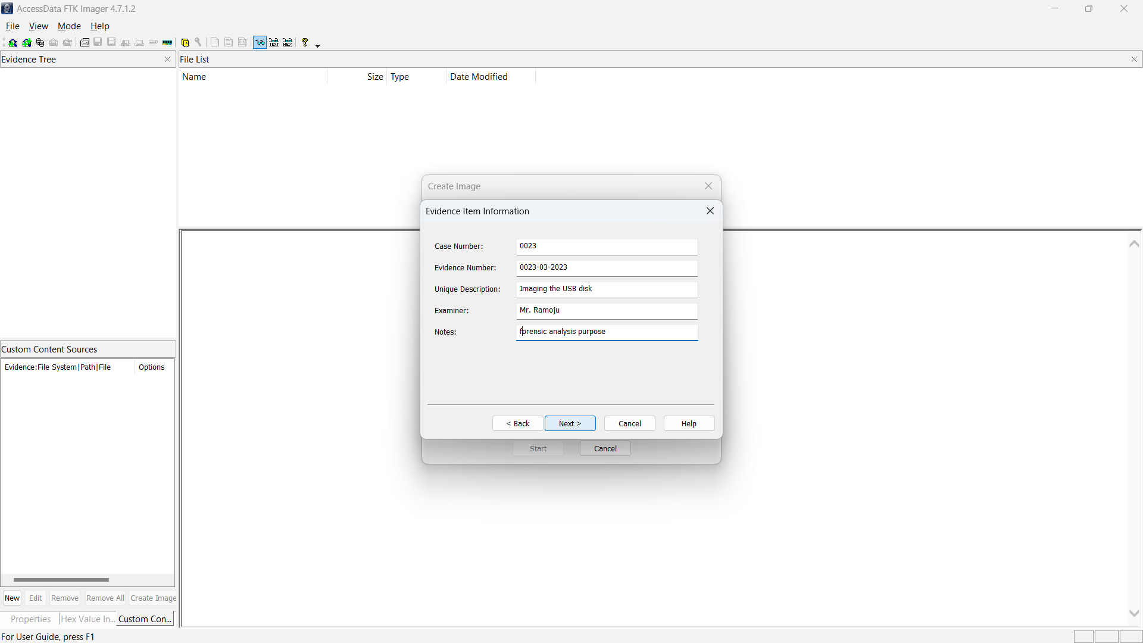

Step 5:- Select the image file destination
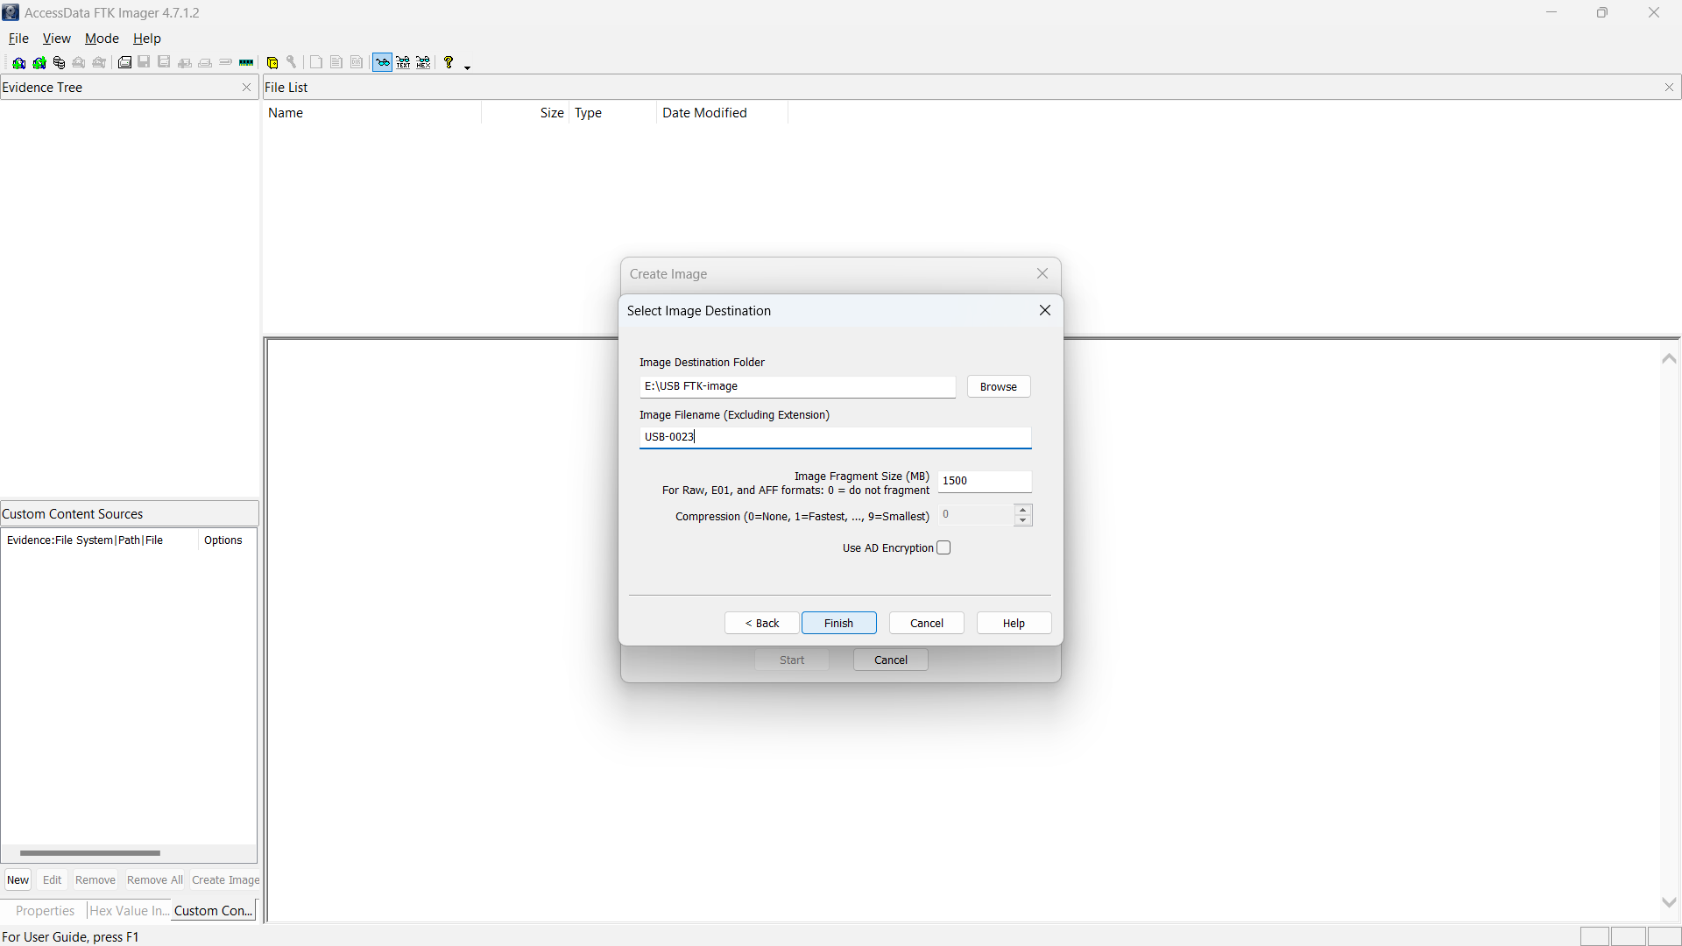

Step 6:- Start the verification of the image
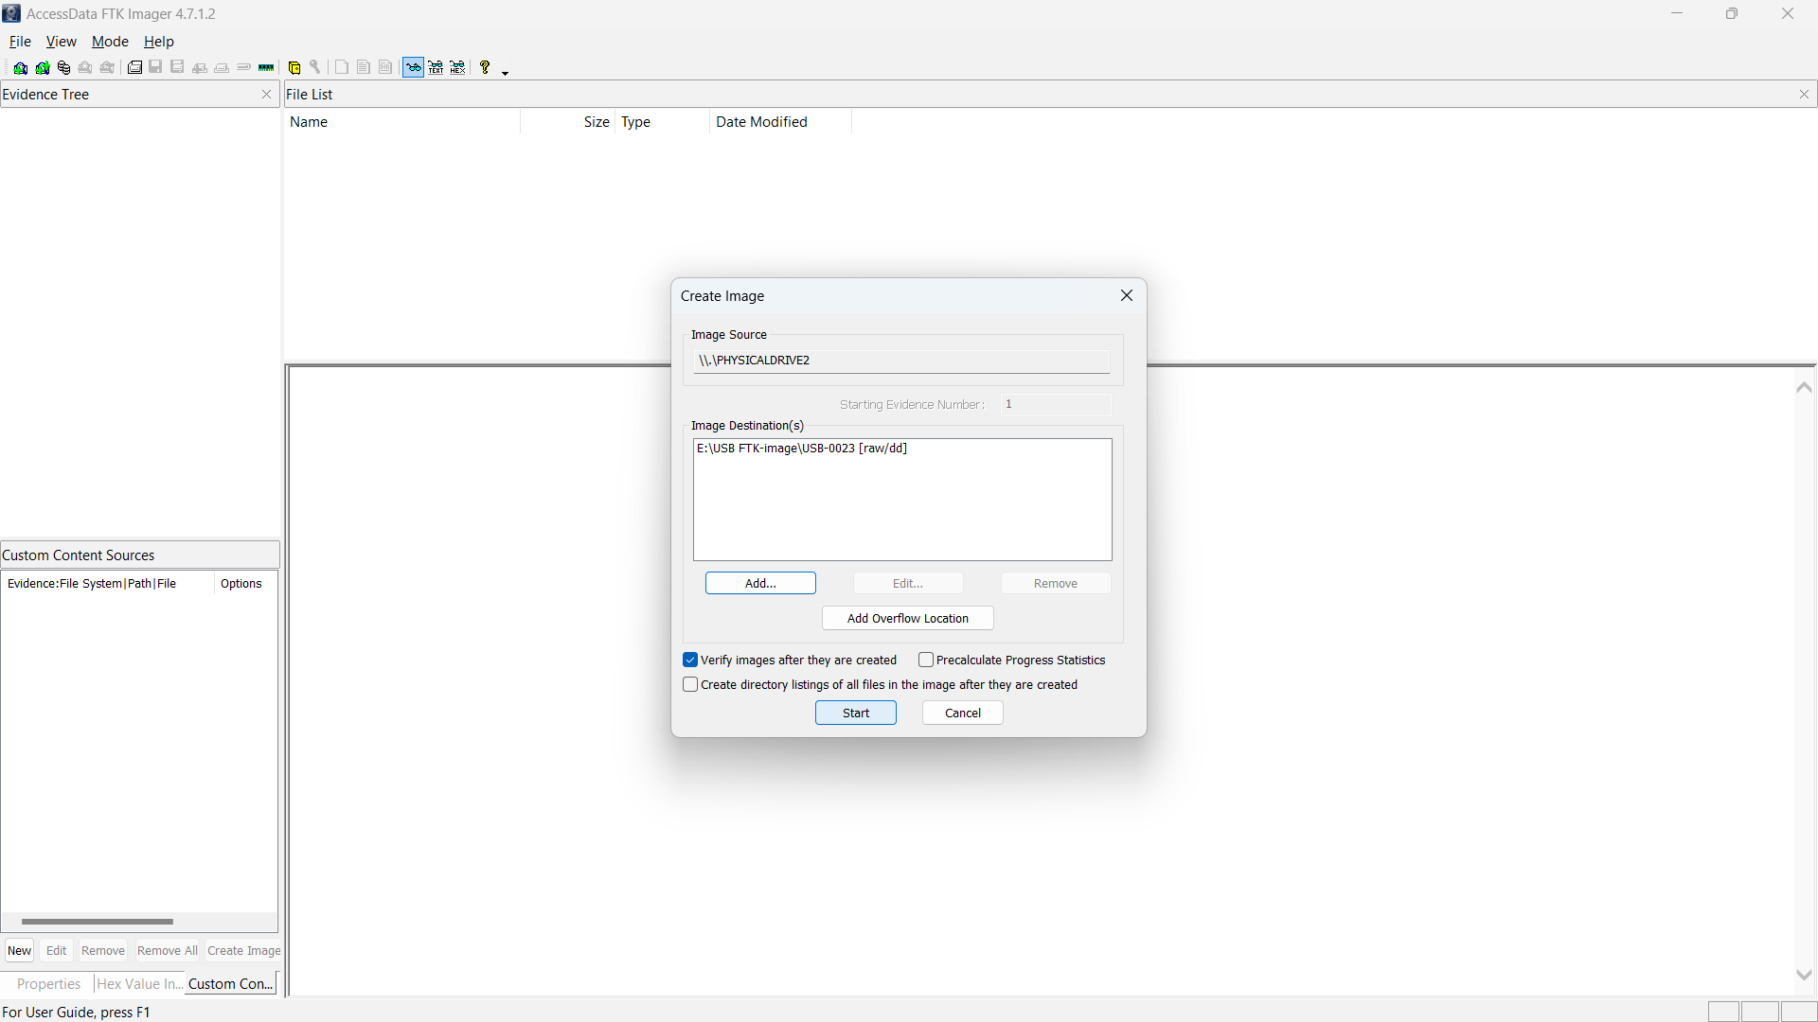

Step 7:- Creating the image
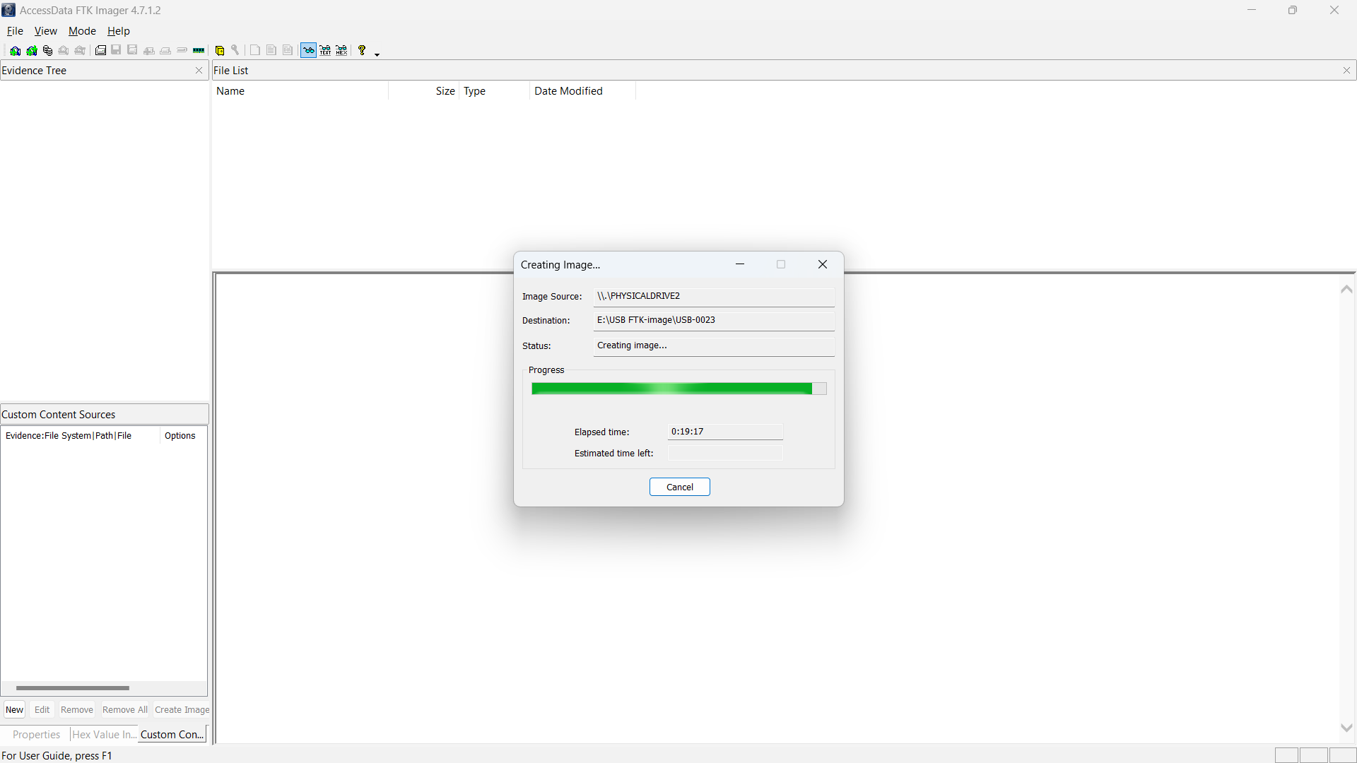

Step 8:- Verifying the created image
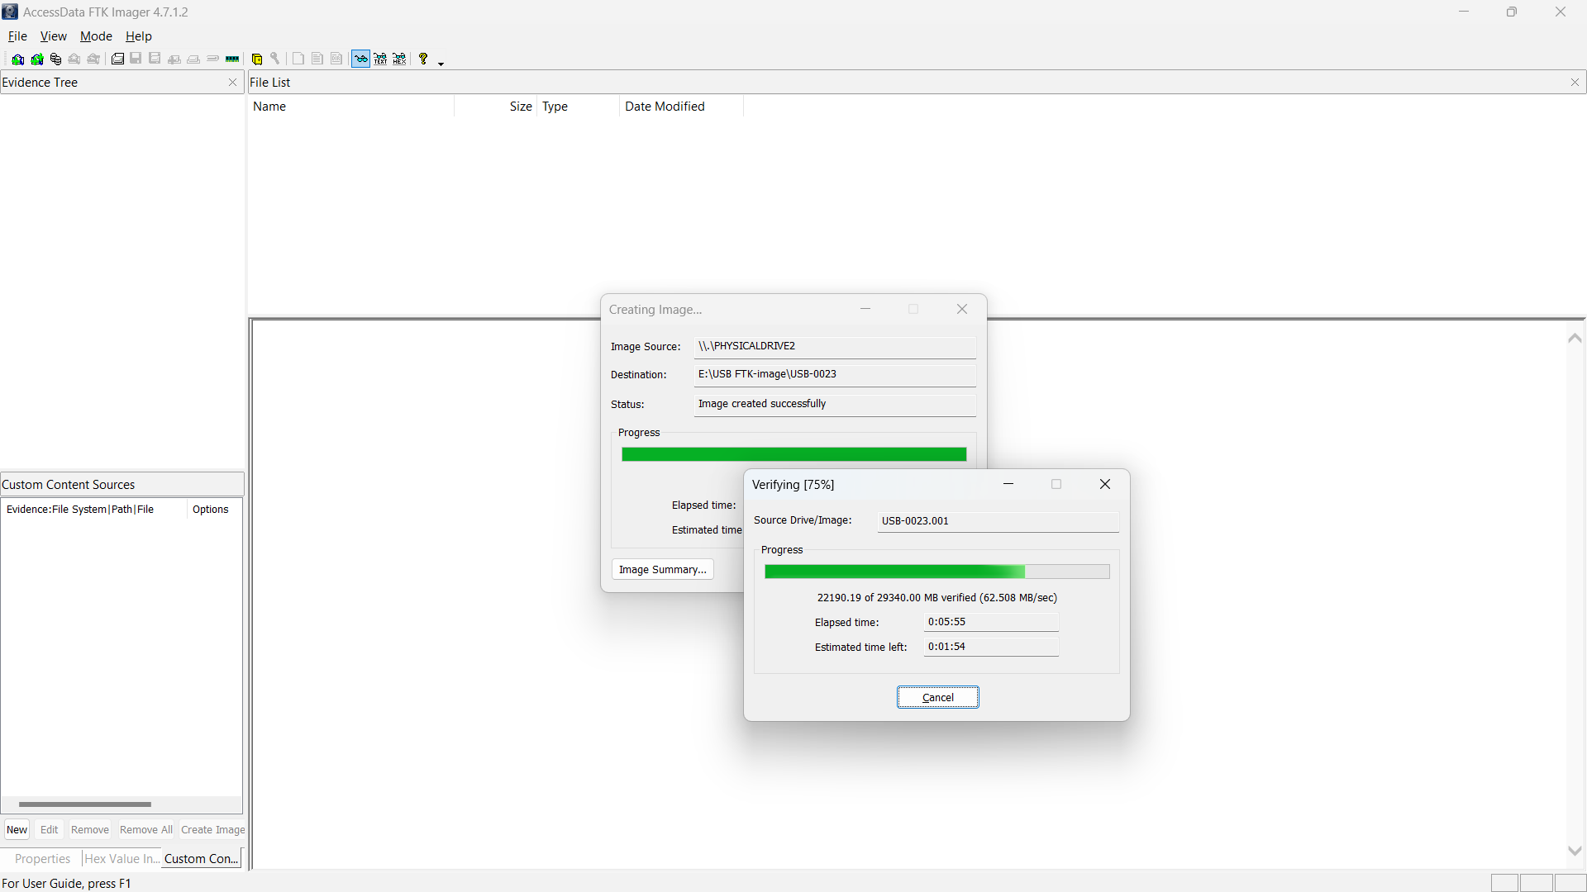

Step 9:- Displaying the created image results
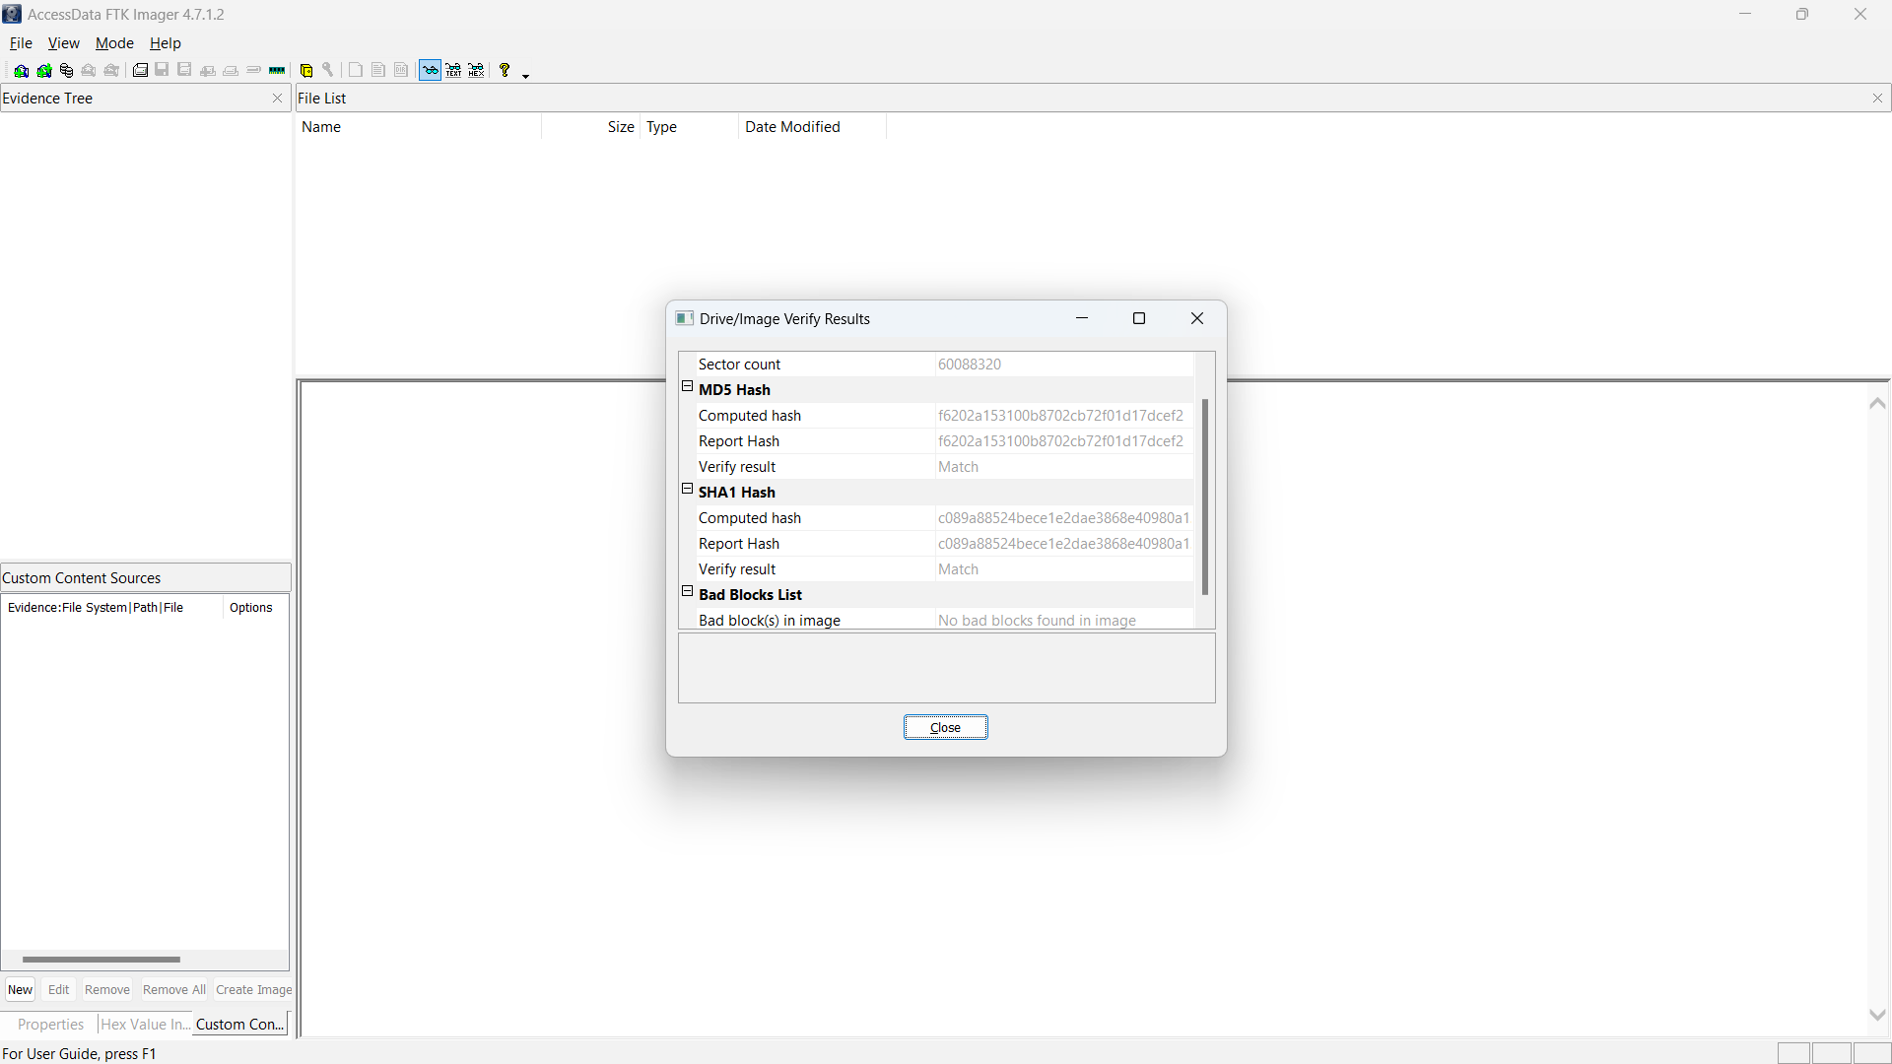

Step 10:- Image created successfully
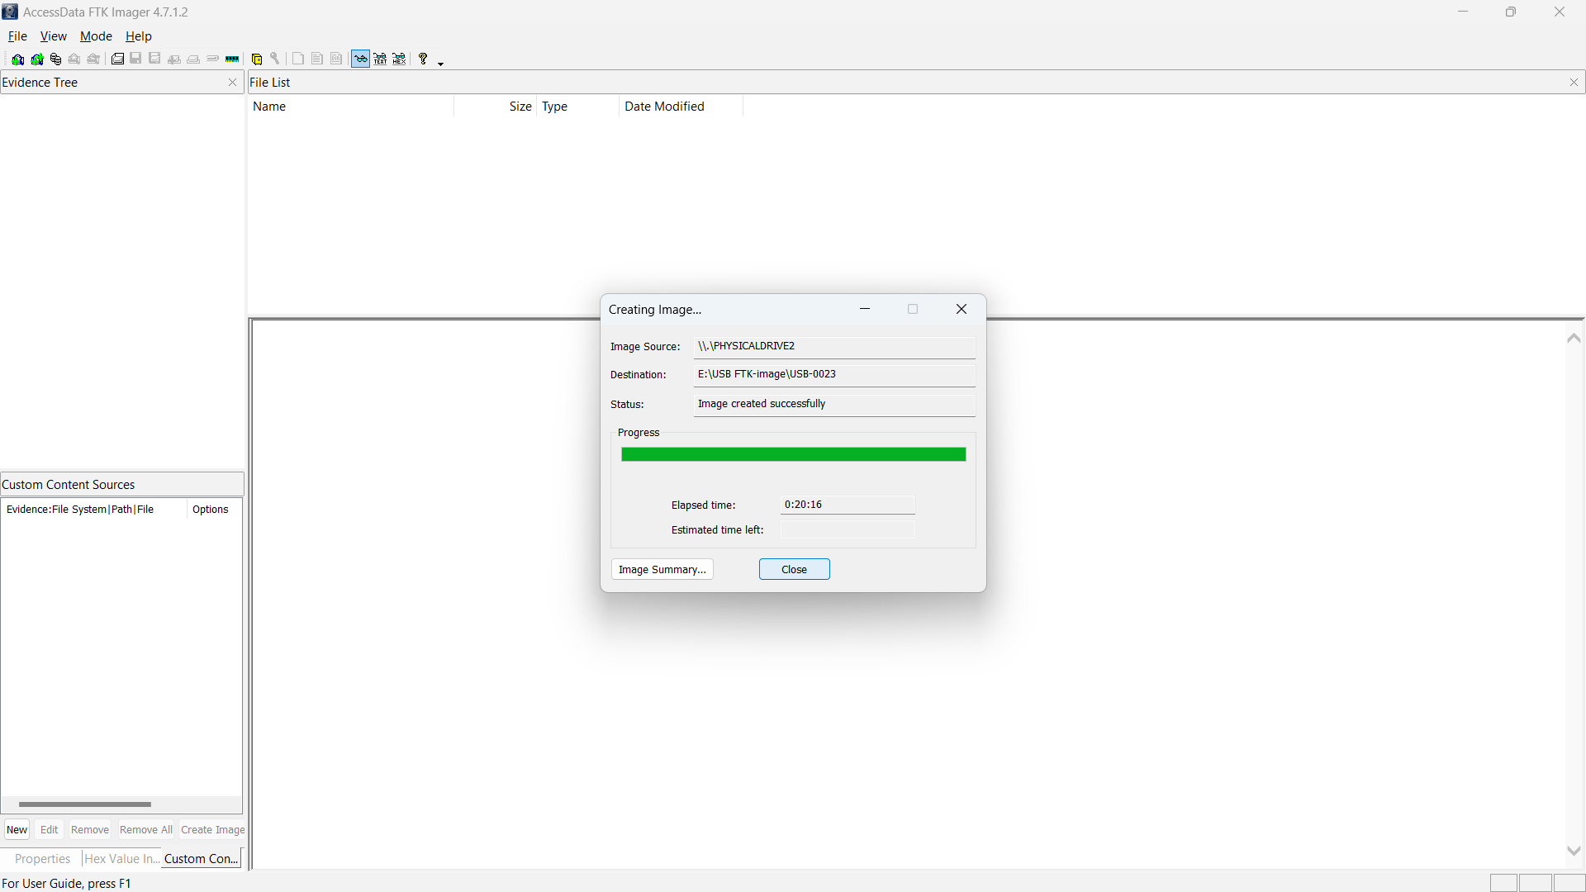

Step 11:- Add created evidence item to the FTK-image software
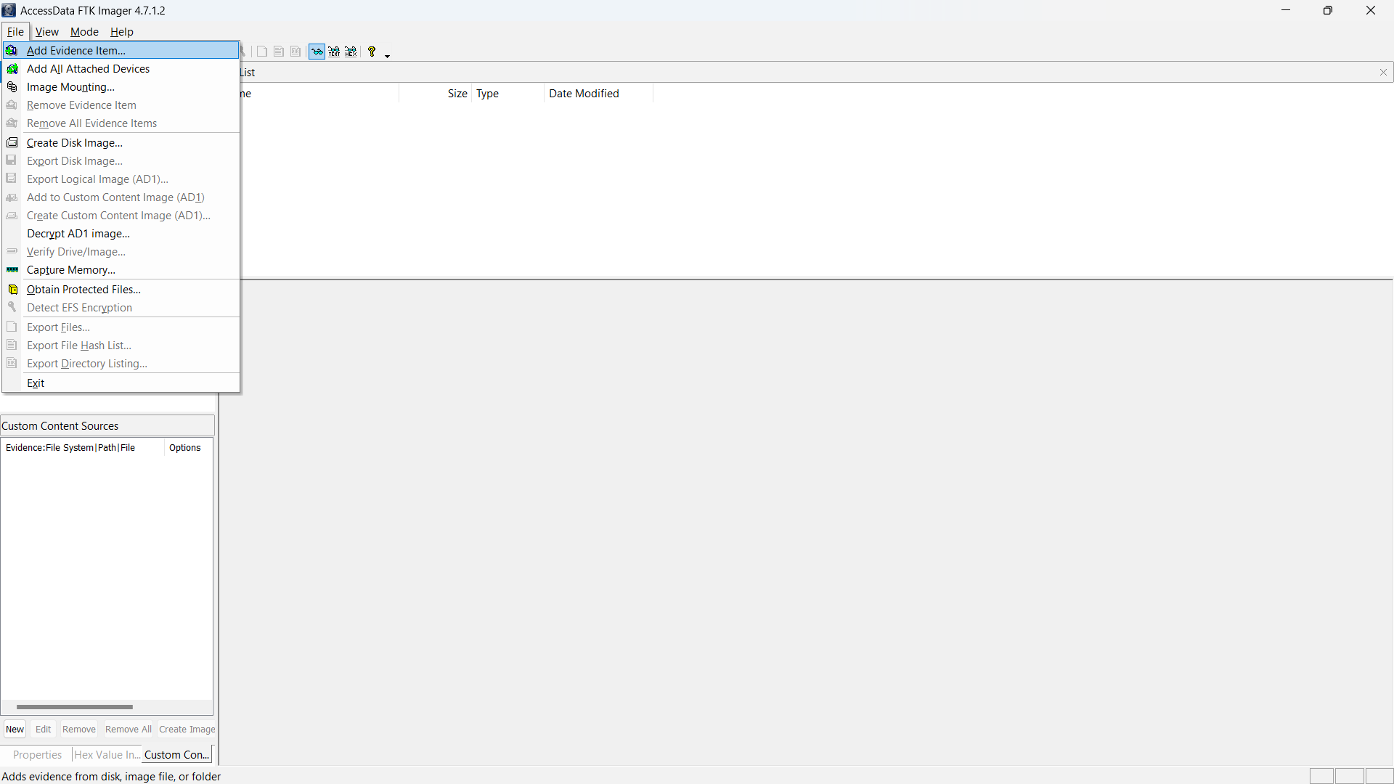

Step 12:- Select the source as Image file
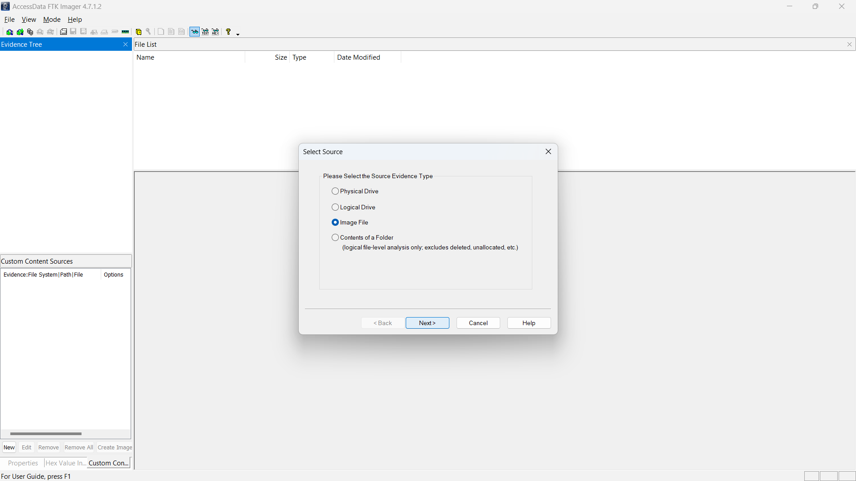

Step 13:- Add the created Image file through the file explorer
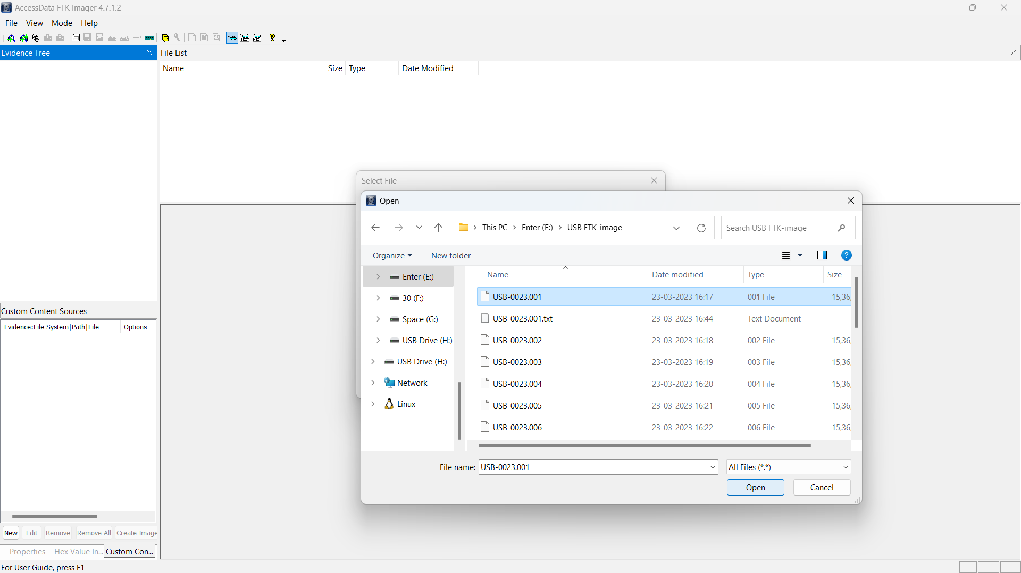

Step 14:- Image result in the form of Binary format
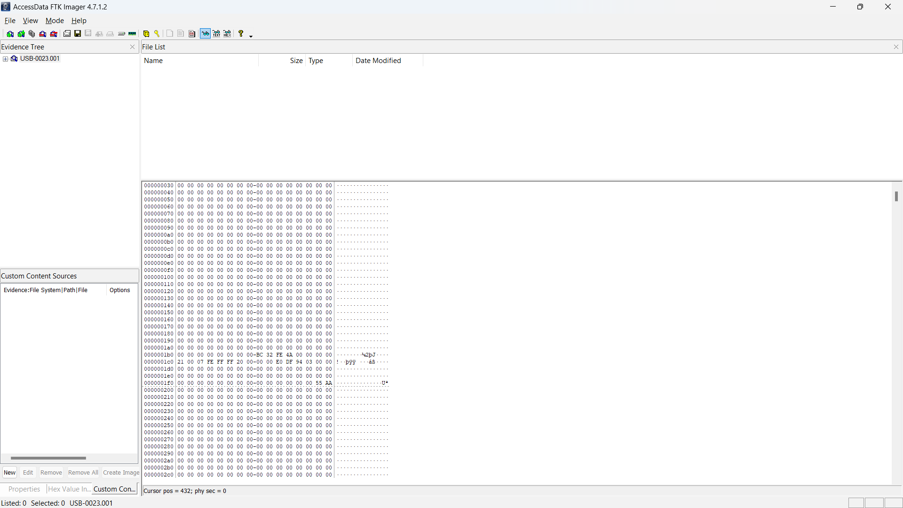
USB-disk image created successfully…

